Biological Drawings Booklet
Name:
Class:
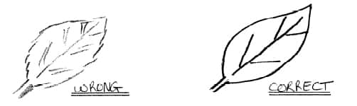
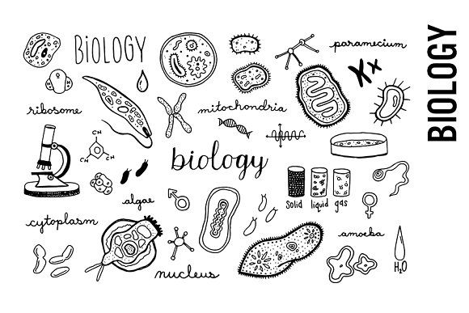
Starter:

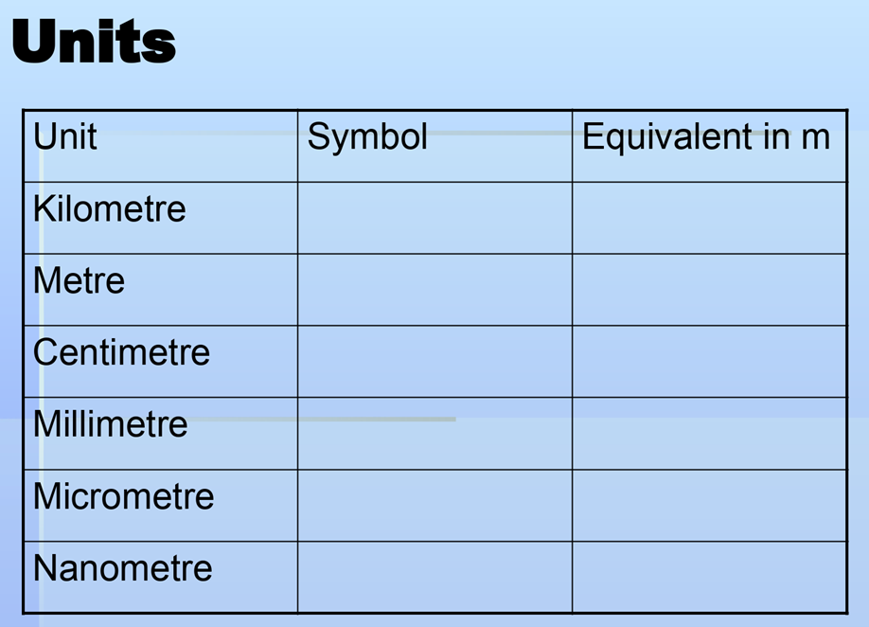

EXT:
Convert 389nm into km. Show your workings.

Task 1: Spotting issues with a biological drawing:

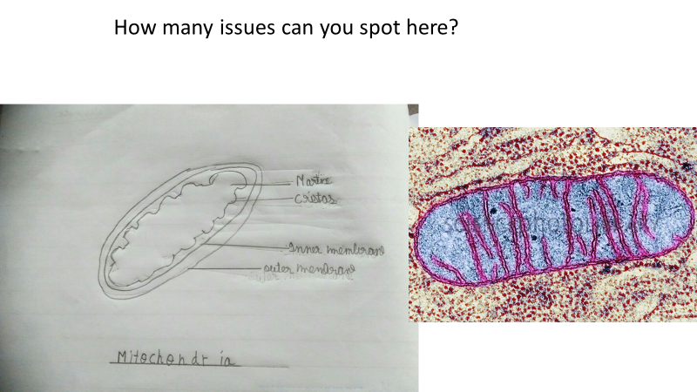
Example:

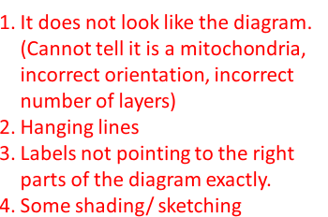

Be the examiner:
Use the following mark scheme to give each of the 2 diagrams a mark out of 4. Assume for all the magnification is x62,800.
For each one explain why you have awarded the marks.
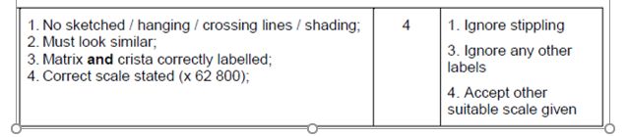

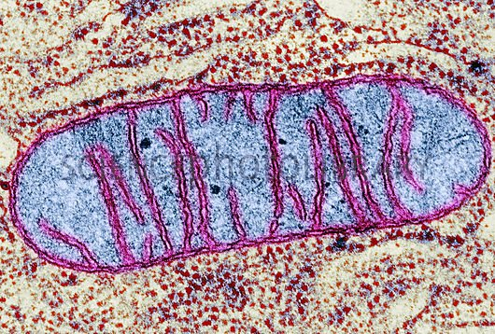

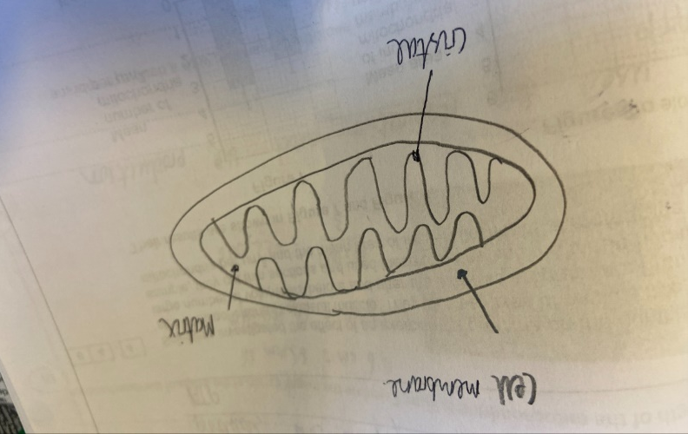
1.

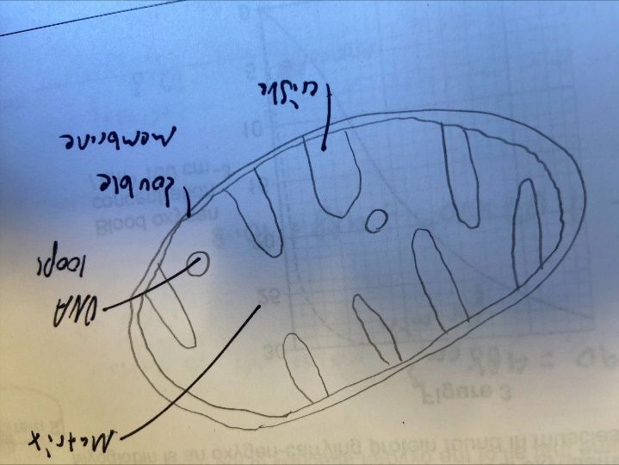

2.

Complete your own biological drawings now of the following. For each one try and label some key parts of the structure:
Key tips:
-If doing a tissue don’t draw individual cells
-Ensure labels are precise and finish at the exact point you are trying to label
-You will be unable to include magnification
-Take your time and use a sharp pencil.
-Ensure all lines join and there are no hanging lines or crossing lines.
- Cheek Cell
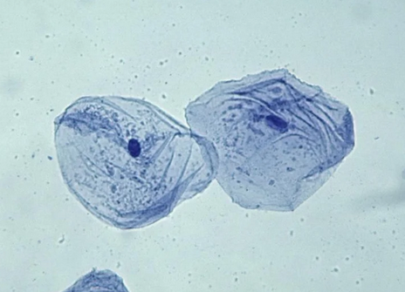

#
- Chloroplast

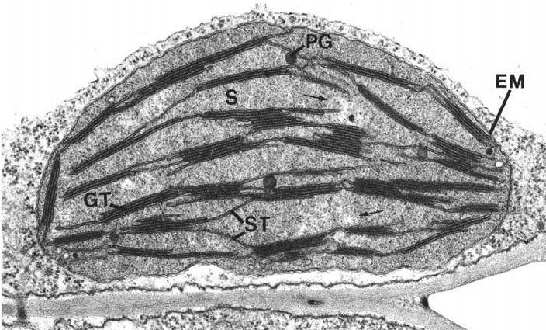

- The heart (External structure)
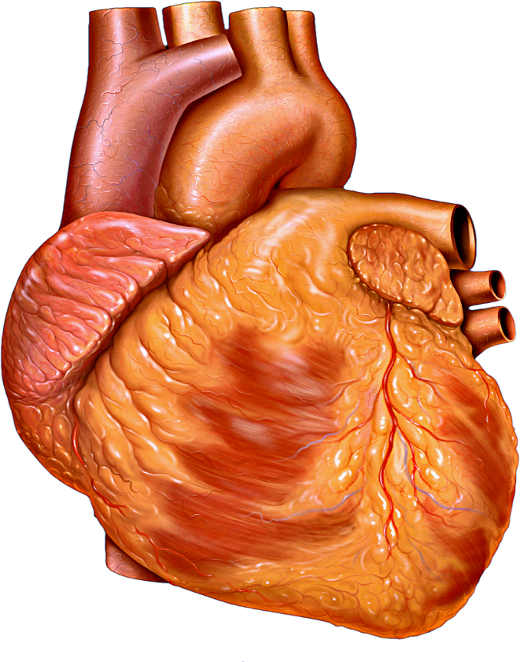

- External Structure of a dicotyledonous leaf
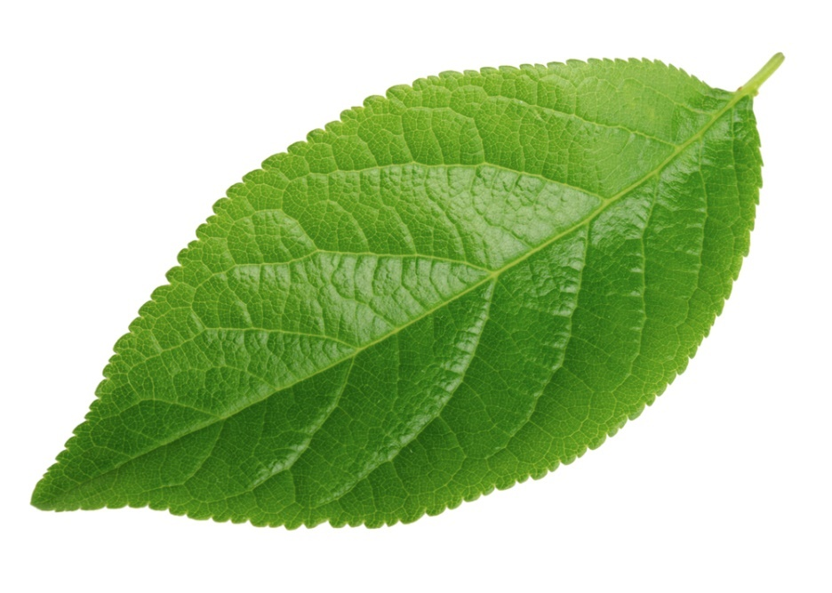

- Cross section of a dicotyledonous leaf.
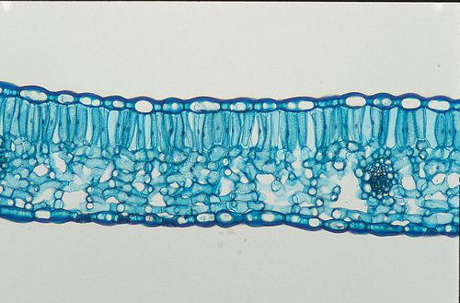

Exam Questions:
Q1. A student dissected an organ from a mammal to observe blood vessels.
He dissected a slice of the organ and identified two blood vessels.
Figure 1 shows a photograph of his dissection.
Figure 1
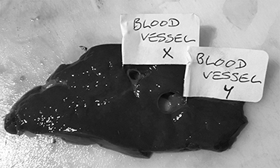
Figure 2 shows a drawing of the blood vessels from his dissection.
Figure 2
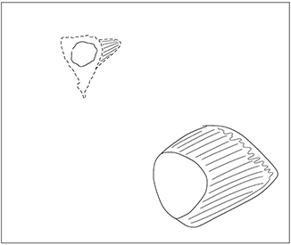
(a) Suggest two ways the student could improve the quality of his scientific drawing of the blood vessels in this dissection.
1 _________________________________________________________
___________________________________________________________
2 _______________________________________________________
___________________________________________________________
(2)
(1)
(b) Figure 2 shows a photograph of part of a mitochondrion from a mouse liver cell taken using a transmission electron microscope at × 62 800 magnification.
Figure 2
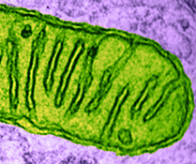
Produce a scientific drawing of the mitochondrion in Figure 2 in the box below.
Label the following parts of the mitochondrion on your drawing.
• Matrix
• Crista
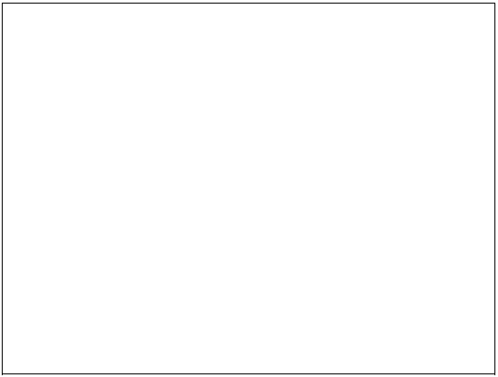
(4)
(Total 8 marks)

