Level 3 Core Maths Summer 2021 Tasks

Percentages
1 Circle the multiplier that is equivalent to a percentage increase of 15%
[1 mark]

0.015 0.15 1.015 1.15

2 A train fare costs £23.55
All train fares are increased by 2.8%

Work out the new fare.
[2 marks]
3 A savings account pays 3.6% per annum simple interest.
Heidi puts £400 into the account.

How much will she have in the account after 5 years?
[2 marks]

4
SHOP B

Normal Price £80

30% off
SHOP A

Normal Price £85

off

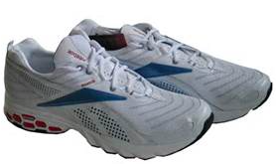

In which shop are the trainers cheaper?
You must show your working.
[3 marks]

5 In one week the mass of a puppy increases from 1.8 kg to 2.25 kg

Work out the percentage increase of the mass.
[2 marks]

6 In a sale all items are reduced by 30%
On the final day the sale prices are reduced by 20%

Work out the final day price of a sofa that was priced at £290 before the sale started.
[3 marks]

7 This is the advert for a new car.

 |  | Why pay cash?  Our credit charges are less than 2% of the cash price each year.
Cash Price | Credit Price
£10 345 | Deposit  24 monthly payments of  Final payment of |  | £1350 +  £191.36 +  £4887.50

Is the claim in the advert true?
[4 marks]

8 After a 10% decrease the cost of a new cooker is £198

Work out the original price of the cooker. [3 marks]

Averages
1 Below is a list of data.
5 1 9 3 2 5 6 7 1 1

1 (a) Calculate the mean.
[2 marks]
1 (b) Write down the mode.
[1 mark]

2 Sally made a table showing the number of siblings people had in her class.
Siblings | Frequency
0 | 4
1 | 10
2 | 12
3 | 3
4 | 0
5 | 1

Calculate the mean number of siblings in in Sally’s class.
[3 marks]

3 Ben catches a train to work in a morning.

This table shows the time in minutes the train was late over a period of 20 days.

Time (t) in minutes | Frequency
0 ≤ t < 5 | 12
5 ≤ t < 10 | 5
10 ≤ t < 15 | 1
15 ≤ t < 20 | 2

Estimate the mean number of minutes the train was late.
[4 marks]

Probability
1 In a raffle there is one winning ticket.
In total 360 tickets are sold.

1 (a) Rachel buys 12 tickets.
What is the probability she buys the winning ticket?
Give your answer as a fraction in its simplest form.
[2 marks]
1 (b) How many tickets should Zain buy to have a chance of winning?
[2 marks]
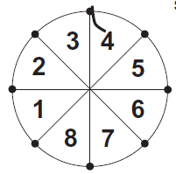
2 In a game, a player spins this wheel.
The wheel is fair.

What is the probability that the player scores

2 (a) an even number greater than 2?
[1 mark]
2 (b) a prime number?
[1 mark]
2 (c) a square number?
[1 mark]
2 (c) a number that is a factor of 24?
[1 mark]

3 There are 40 counters in a bag.

Three-eighths of the counters are yellow.
One-fifth of the counters are red.
The rest of the counters are blue.

One counter is chosen at random.
Work out the probability that the counter is blue.
[4 marks]
4 A class of 30 students are asked about their favourite hobby.
The results are shown in the table. Some of the values are missing.
Hobby | Boy | Girl | Totals
Playing football |  | 2 | 10
Reading | 2 | 1 | 3
Watching TV | 5 |  | 9
Playing computer games | 3 | 5 | 8
Totals | 18 | 12 | 30
A student is chosen at random.
Work out the probability that the student is:
4 (a) a boy whose favourite hobby is playing football
[2 marks]
4 (b) a girl whose favourite hobby is not reading
[2 marks]
The teacher chooses a student at random from the class and it is a boy,
4 (b) Work out the probability that his favourite hobby is either watching TV or playing computer games.
Give your answer as a fraction in its simplest form.
[3 marks]
5 A farmer collects some eggs from his hens one morning.
The eggs are either brown (B) or white and are sorted into small (S) and large sizes.
The Venn diagram shows the results.

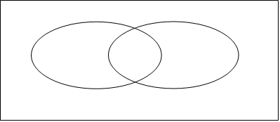
45
20
25
30
S
B
Two eggs are chosen at random.
5 (a) Work out the probability that the first egg is large and white.
[2 marks]
5 (b) The first egg was small.
Work out the probability that the second egg is small.
[1 mark]

6 The probability that a biased dice lands on a 3 is 0.25
The dice is rolled twice.
6 (a) Complete the tree diagram.
[2 marks]
1st roll
2nd roll

Not 3
3
3
Not 3
3
Not 3
0.25

6 (b) Work out the probability that both rolls are not a 3.
[2 marks]
6 (c) Work out the probability of scoring exactly one 3
[2 marks]

7 A large park has thousands of flowers. The flowers are pink, yellow or blue.
55% of the flowers are pink and the ratio of yellow to blue flowers is 2 : 1

7 (a) Complete the table to show the relative frequency of each colour of flower in the park.
[3 marks]

Flower  colour | Yellow | Pink | Blue
Relative
frequency

7 (b) Bees visit the flowers to get pollen to make honey.
The probability that flowers are visited by a bee are shown.

Flower  colour | Yellow | Pink | Blue
Probability of being visited by a bee | 0.6 | 0.3 | 0.75

Produce a tree diagram in the space below to show all the information from (a) and (b)
[5 marks]

Statistical Diagrams
1 Anna, Beth and Cal bake and sell cakes.
Beth and Cal sell 50 cakes in total.
Beth sells 6 more than Cal.
1 (a) Draw the bars for Beth and Cal on the bar chart.
[2 marks]

Number
sold

Cal
Beth
Anna

1 (b) It costs Anna £1.50 to bake a cake.
She sells them for £5 each.

How much profit does Anna make selling all her cakes?
[3 marks]

2 The diagram shows the number of goals scored by a team in 20 matches.

Number of matches
Number of goals scored

2 (a) How many times did the team only score 2 goals in a match?
[1 mark]

2 (b) At the end of the season the team had played 24 matches.
They scored 40 goals in total.

How many goals did they score in the last 4 matches?
[2 marks]

3 The pie chart shows information about the number of students attending four colleges.
College
B
College A
College C
College D

3 (a) What percentage of the total attend College C?
[1 mark]

3 (b) Compare the number of students at College A with the number at the other colleges.
[1 mark]

3 (c) 1200 students attend College D.

How many students attend all the colleges?
[3 marks]

4 The times spent cycling and running on ten days are shown on the scatter graph.

Time running (minutes)

Time cycling (minutes)
4 (a) The average time spent cycling per day on the ten days is 175 minutes.
The average time spent running per day on the ten days is 160 minutes.
Plot the point (175, 160) on the graph.
[1 mark]
4 (b) Draw a line of best fit through the data.
[1 mark]
4 (c) On another day he spends 150 minutes running.
Use a line of best fit to estimate the time he spent cycling.
[1 mark]
4 (d) On another day he did no running and no cycling.
What assumptions can you make about the effect this data would have on the result in
part (c)? [1 mark]
5 Sara cycles home from work each day.
The scatter graph shows information about her journey times.

Leaves work (pm)
Arrives home (pm)

5 (a) Sara leaves work at 5.12 pm

Use a line of best fit to estimate the length of her journey home.
[3 marks]

Fermi Estimation
During the course you will learn about Fermi estimation which will help you to estimate answers to problems such as: He challenged his students to use estimation, common sense and numerical reasoning to work out quantities that were difficult or impossible to measure. He deliberately posed questions with limited information so that students had to ask more questions. His questions emphasise the process rather than the answer.
To answer these questions:
Step 1: Make your assumptions- these can be whatever you think it reason and will vary from student to student.
Step 2: Use your assumptions in a calculation that will lead you to the answer.
Example
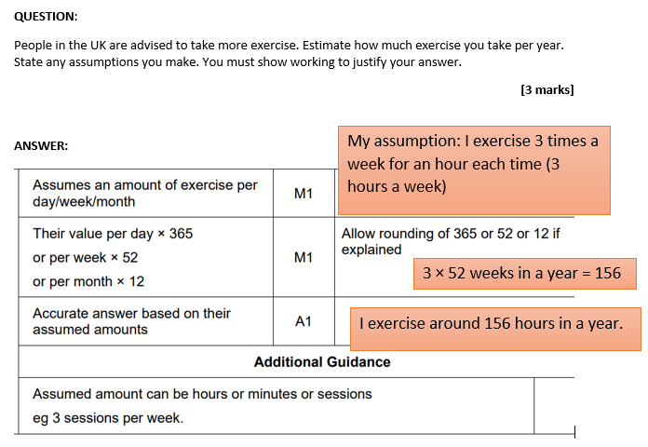

Using Fermi estimation and stating the assumptions you have used have a go at the questions below.
* How many times could you say the alphabet in 24 hours?
* How many metres of spaghetti would be needed if all of the children in a school had spaghetti bolognese for lunch?
* How many ping pongs balls would it take to fill the classroom?
* How many balloons would it take to fill the school hall?
* How many people would fit shoulder to shoulder in the corridor outside our class?
* If all the people in the world moved to Wales, how crowded would it be?
* How many litres of water does the school use each week?
* How many sweets in a 2 litre jar?
* How many hairs on your head?
* How long would it take to count to one million?

