Heads – Summer transition work

Artist Sarah Simblet
Look carefully at Artist Sarah Simblet’s head and anatomy studies. Complete your own accurate reproductions using black biro onto paper (newspaper/cartridge/ colour-washed/ sugar paper etc. – just try to avoid white and plain paper.
Experiment with a range of sizes but no larger than A4

The work will be added to your first few pages of your Y12 sketchbook
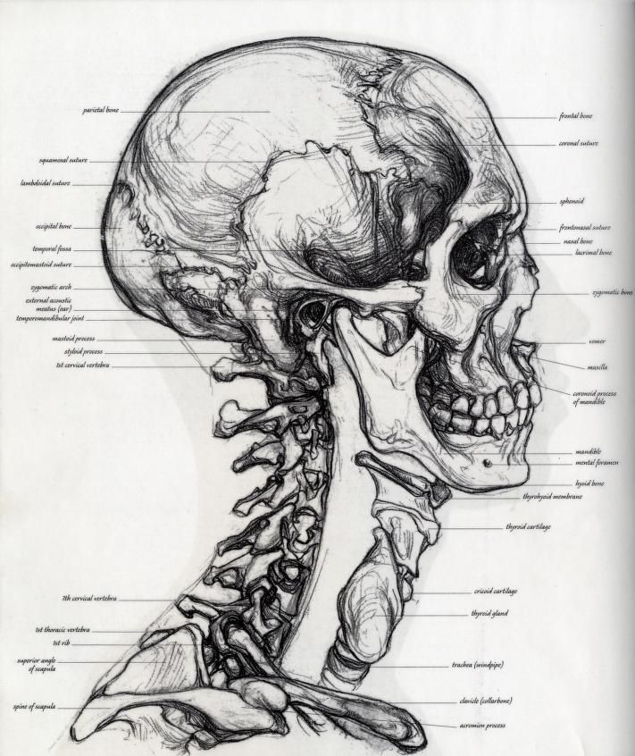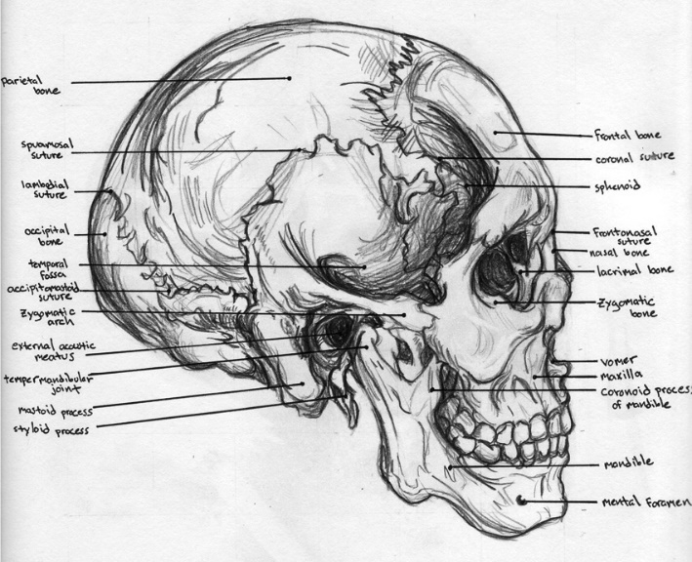

Jean Michel Basquiat
Collect information on the artist.
- Background – what was his relationship with Artist Andy Warhol? How did this begin and how did it develop?
- What type of work was Basquiat doing before he met Andy Warhol and how did this change over time?
- Make small loose studies in mixed-media and media of your choosing that explore ‘heads/skulls’ by Basquiat

