Pre-A Level History: transition task, 2026
All work to be completed by Monday 13th July.
In September, you will be studying the AQA A Level History course. This is divided into 3 sections:
- Paper 1- The Tudors, 1485-1603- 40% A level Exam
- Paper 2: The American Dream: Reality and Illusion, 1945-1980- 40% A level Exam
- Coursework: Your choice- 20% Independent enquiry study
To be accepted onto the History course, you MUST complete these tasks before the summer holidays and email to Mrs Carew-Rendall by Monday 13th July. (scarew@coombedean.co.uk)
We expect you to complete the work below to show you have completed the background research and are capable of studying at A Level. Failure to complete this work to a sufficient standard may result in you not being able to join the course.
These tasks will take a total time of approximately 8-9 hours, please do not leave this to the last minute! You need to show you can manage your own time to be suitable for A level History- this task is a test of your suitability.
TASK 1: SENECA
Complete the Seneca assignments set- see the hyperlinks or see below. You will need to set up an account on Seneca if you don’t already have one. The class code is mmamapb3gw and links to assignments are below. www.senecalearning.com
Total time = 2-3 hours
TASK 2: TIMELINES
Using the timelines you have been given for each topic, research every event and create your own timeline with a detailed description of each event.
Total time = 4-6 hours
Email your timelines to Mrs Carew-Rendall by Monday 13th July.. If you have completed it by hand, take a photo and upload. Teachers will check the logs and scores on Seneca. scarew@coombedean.co.uk

Seneca class code: mmamapb3gw

Transition task 1: Tudors
https://app.senecalearning.com/dashboard/class/mmamapb3gw/assignments/assignment/ef58ad6c-7c6c-414c-a59f-b7f1f36a2251

Transition task 2: American Dream (shows up as Cold War on Seneca)
https://app.senecalearning.com/dashboard/class/mmamapb3gw/assignments/assignment/045b75c6-8b60-4560-8373-29fdee0e68ed
Enjoy! I look forward to seeing you all in September! Mrs Carew-Rendall😊
If you have any questions about the transition tasks, please email Mrs Carew-Rendall (Subject Leader for History) scarew@coombedean.co.uk

AQA History A level Core texts

The core texts for the course that you need to purchase are below. The revision guides are recommended, but not compulsory. The hyperlinks take you to amazon.co.uk to purchase new, but remember to check for ‘used’ copies on amazon, ebay and other sites.

Recommended resources

The core texts for the course that you need to purchase are below. The revision guides are recommended, but not compulsory.

The hyperlinks take you to amazon.co.uk to purchase new, but remember to check for ‘used’ copies on amazon, ebay and other sites.
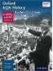American Dream:

Oxford AQA History for A Level: The American Dream: Reality and Illusion 1945-1980 (Oxford A Level History for AQA) Paperback – 1 Oct. 2015
by Sally Waller (Author), Mark Stacey (Contributor)
Link to amazon.co.uk RRP: £26.50
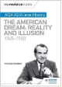
My Revision Notes: AQA AS/A-level History: The American Dream: Reality and Illusion, 1945-1980 Paperback – 26 Jan. 2018
by Vivienne Sanders (Author)

Tudors:

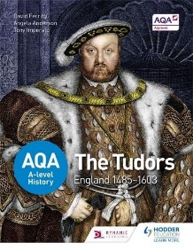
AQA A-level History: The Tudors: England 1485-1603 Paperback – 26 Jun. 2015
by David Ferriby (Author), Angela Anderson (Author), P A Imperato (Author)
Link to amazon.co.uk RRP: £32
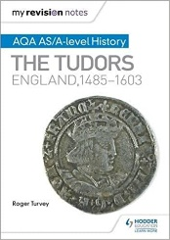

My Revision Notes: AQA AS/A-level History: The Tudors: England, 1485-1603 Paperback – 25 Nov. 2016
Link to amazon.co.uk RRP: £11.99

